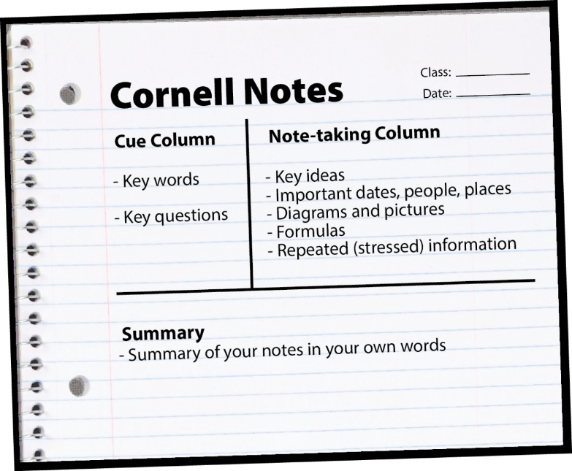
Class: __________________________________
Date: __________________________________
Cues: Notes:

Summary:

