Directions: For each problem, you are asked a question regarding two or more ratios that must be compared.

Two SRNAs are moving hospital patients to rooms on a different floor. Part of their data is modeled below:

First SRNA
Patients |  |  | 8 |  |  | 16
Time in minutes |  |  | 12 |  |  | 24
Second SRNA
Patients |  | 12 |  |  |  | 36
Time in Minutes |  | 20 |  |  |  | 60

Which SRNA is able to move patients more quickly? Justify your answer below.

In the chart below, which shift has the greatest ratio of Licensed Nurses to Certified Aids?
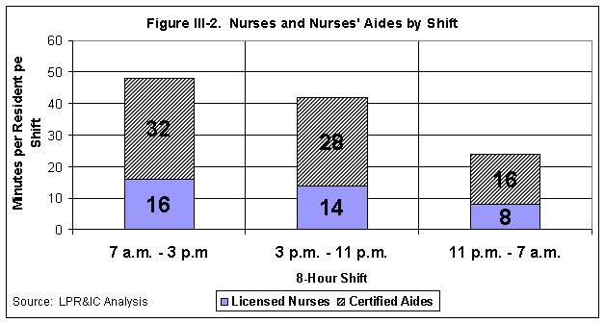

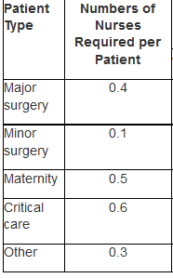
In the image to the right, patients and nurses are mandated to have specific proportions based on the type of service the hospital provides.

- Which hospital service has the highest nurse-to-patient ratio?

- If there are 36 patients in Critical Care and 36 patients in Major Surgery, how many nurses are required for each?

- If there are twenty nurses available for Maternity and twenty nurses available for Minor Surgery, how patients can be admitted into each?

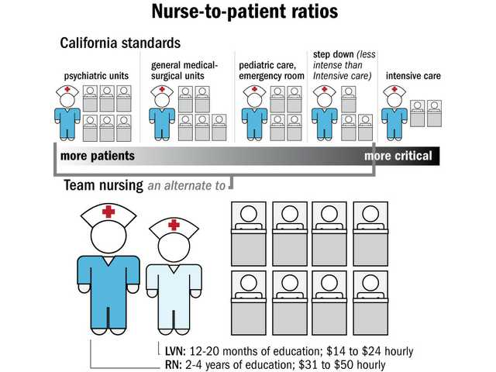
In the chart below, several Nurse-to-Patient ratios are given.

- According to California standards, if there are forty beds in “general medical-surgical units” and forty beds in the “pediatric care, emergency room”, how many nurses must be present in each?

- If the alternative “Team Nursing” is used in a hospital, what is the ratio of nurses (of any type) to patients? What other model does “Team Nursing” most closely mimic?

Three graphs are given below. Which graph most closely resembles a proportional relationship? Why?

Graph A

Graph B Graph C

