Formula Challenge!
In order to successfully use formulas for the Mathematics sections of the GED test, you will need to pay close attention to the details of the questions that are asked. Be sure to pay close attention to the units being used and what dimensions are actually given. You will not always be given the dimensions that the formulas ask for. You may have to find a dimension or even use another formula to find the dimension. Take a look at the next few problems and try to answer the questions being asked.
- Jacob is looking to buy a fish tank for his son’s room. He knows he wants a tank that will hold 30 cubic feet of water. The base can be no more than 3 feet long and 2 feet wide. What would the height of the tank be?

- Candi is building planters for her patio. She wants each one to hold 8 cubic feet of dirt. The height of each planter will be 2 feet. If the base of the planter is a square, what is the length of each side of the base?

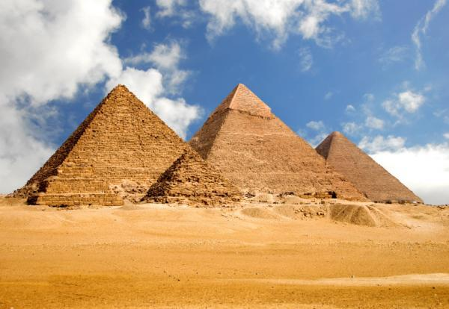
- Sarah is working on a project for her Social Studies class. She knows that the volume of the large pyramid in Egypt is 2,592,100 m³. She also knows that the base is 52,900 m². She needs to find the height of the smaller pyramid and all the information she has is that it is 1/3 the height of the larger pyramid. What is the height of the smaller pyramid?

- LearnZillion Problem
A square house has a pyramid-shaped attic built under the roof, which you are converting into a spare bedroom. You are installing an air conditioner to cool the room. The perimeter of the base of the room is 190ft, and the attic height is 6ft. How many cubic feet of air are in the empty attic?
(*Highlight the key details in the problem before working the problem.)

