Instructional Delivery:
When solving mathematical problems, you first have to be sure you know what the problem is asking and what information is given. You will also need to be sure to use the appropriate sources needed to solve the problems. When asked questions about the volume of an object, you will need to know the shape of the object and which formula to use. You will need to determine if you are asked to find the volume or maybe a missing side length. You may even have to convert units of measure depending on the information given in the problem.
Volume of Rectangular Prisms
Pay close attention to the following rectangular prisms.
Can the volume of each of the rectangular prisms be calculated? Will the volume be the same or different?
What information do you need to calculate the volume? What do you need to pay close attention to?

6 ft
2 ft
6 ft
2 ft
2 ft

2 ft

Compare the following two rectangular prisms. Can their volumes be calculated? Will the volumes be the same or different? What information do you need to calculate the volume? What do you need to pay close attention to?
48 in

24 in
2 ft
4 ft
24 in
2 ft

Volume of right prisms
Take a look at the following right prisms.
How are they different from the rectangular prisms?
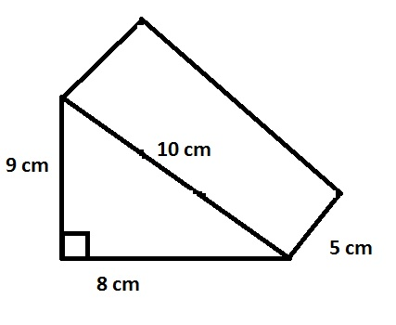
How will calculating the volume for a right prism be different than calculating the volume of a rectangular prism?

What is the formula for the volume of a right prism?
What is the base of the prism? What is the height?

Use the dimensions from the picture above. Find the volume of the right prism.

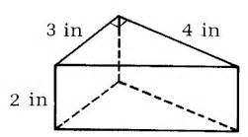
Take a look at these prisms. Locate the base and height. What information do you need to solve for the volume? Find the volume.
6 ft

2 ft

3 ft

Volume of pyramid
Take a look at the following pyramids.
How are they different from the rectangular prisms?
How will calculating the volume for a pyramid be different than calculating the volume of a rectangular prism?
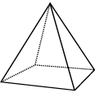
6 in

3 in

What is the formula for the volume of a pyramid?

What is the base of the pyramid? What is the height?

Use the dimensions from the picture above. Find the volume of the pyramid.

Look at this pyramid. What information do you need to solve for the volume? Locate the base and height. Calculate the volume.

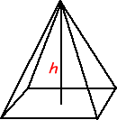
The pyramid has a base edge with a length of 22 cm and a height of 48 cm. What is the volume?

