Activating Activity:
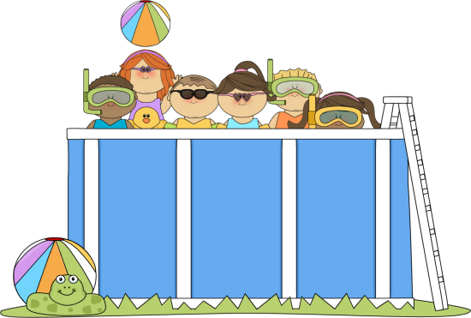
I need to fill my swimming pool for the summer. I will need to call the local pool supply store to schedule a water delivery truck. The company requires me to tell them the shape and the dimensions of the pool when I call. Why would they need to know the shape and dimensions?
During the last lesson the pool was rectangular in shape. What if our
pool is shaped like a cylinder? Before the pool was 10 feet wide,
18 feet long, and 5.5 feet deep. Let’s keep the depth the same and
instead of saying the width is 10 feet, for our cylindrical shaped pool,
the diameter will now be 10 feet. Make a prediction. How will the
volume and costs change?

Volume: Discussion
Let’s discuss the formulas in detail and then come back to the pool problem!
Use the formulas on the GED formula sheet.
Figure | Volume Formula | Name each variable | Describe each piece of the formula using the help of a net
Cylinder | V=
Cone | V= |  | 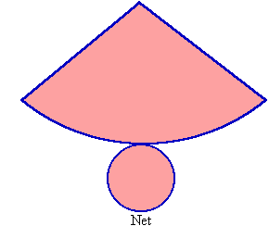
Sphere | V= |  | 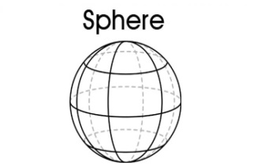

Formula Discussion - continued
How is the volume formula for a cylinder similar to the volume formula for a prism?

How are they different?

How is the volume formula for a cone similar to the volume formula for a pyramid?

How are they different?

Can you prove that the volume of the cone is 1/3 the volume of the cylinder?
What information from the last lesson would help you to do this quickly?
Create a cylinder and a cone with the same radius and height. Compare the volume.

Sphere discussion:
It is harder to see the way the volume of a sphere could be compared to that of a cylinder. Take a look at this…
If you had a sphere made of clay that had a 2 inch diameter and place a cylinder around the ball of clay that was the same height of the clay. The cylinder would have the same radius
and the same height as the ball of clay. They do not have the same volume
though, can you see why?

Mash the clay into to shape of the cylinder. How much of the space is taken up by the clay?

What can you conclude from this example?

Try to do the math! Use a 4 inch diameter for the ball of clay.

Compare the derived formula to the actual formula for the volume of a sphere. What do you notice?

