Connections / Extensions:
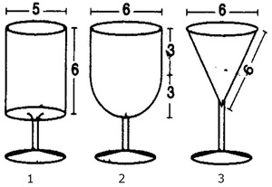
The measurements for all three glasses are in centimeters. The glasses are not drawn to scale.
6
6
6

6

- Find the vertical height of glass 3.

- Calculate the volume of the bowl of each glass.

- Order the glasses starting with the one that will hold the least amount of water to the one that will hold the greatest amount of water.

- Glass 2 is filled with water and then half is poured out. Find the height of the water.

- Compare the volume of glass 1 and glass 3. Why is the volume of glass 3 not equal 1/3 of the volume of glass1?

