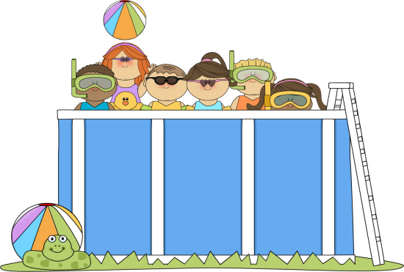
Guided Practice 1
During the last lesson the pool was rectangular in shape. What if our
pool is shaped like a cylinder? Before the pool was 10 feet wide,
18 feet long, and 5.5 feet deep. Let’s keep the depth the same and
instead of saying the width is 10 feet, for our cylindrical shaped pool,
the diameter will now be 10 feet.

The delivery trucks can carry 3,000 gallons of water. They charge$0.04 per gallon and an extra delivery fee of $15 per truck load.

How much water is needed to fill the pool?
(Hint: Use the internet to determine how many gallons of water are in each cubic foot.)

How many trucks are needed?

How much will the delivery cost?

Guided Practice 2
Each scoop of ice cream has a 2 inch diameter and is scooped in a spherical shape. How many scoops of ice cream can the cones hold after the ice cream melts without overflowing if the cones have a 4 inch diameter and a height of 4 inches? (Round to the nearest whole scoop.)

Since you rounded the answer to the nearest whole scoop, will the cone overflow based on the rounded answer?

Guided Practice 3
Tennis balls are packaged in cylindrical containers. The tennis balls have a circumference of approximately 2.6$π$ inches. How many tennis balls will fit in a cylindrical container that has a base area of 1.69$π$ in² and a height of 7.8 inches?

