Instructional Delivery:
During the last lesson you saw how important it is to pay close attention to the details in the problem. Use the formulas for the volume of cylinders, cones, and spheres to solve and compare the following problems. Remember the details from the previous lesson about units of measure.
Volume of Cylinders
Compare the cylinders. Can the volumes be calculated? Will the volumes be the same or different?
6 ft

24 in
6 ft

2 ft

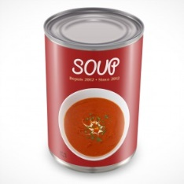
What if you were given the volume of the cylinder and need to determine a missing dimension? The volume of the can below is 50.24 in³. If the height is 4 inches, what is the radius?
4 in

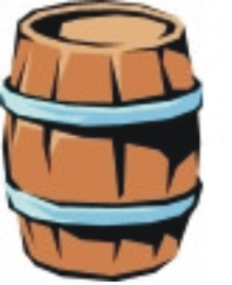
You are given the volume of a barrel and asked to determine if it will sit on a table that is 8 feet wide and 8 feet long. What do you need to determine?
The volume of the barrel is 192.325 ft³. The height is 5 feet. Will the barrel
fit on a table that is 8 feet long and 8 feet wide?

Volume of Cones
We have discussed that cones are 1/3 the volume of the cylinder of the same base and height.
Compare the cylinder and the cone volume.
The two containers have the same radius and the same height. How do the volumes differ?
Both objects have a radius of 5 cm and a height of 8 cm.
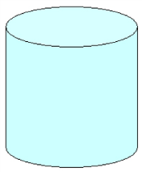
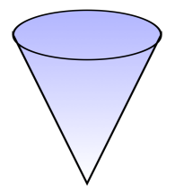

The cone and the cylinder have the same volume of 4220.16 cm3. And both have a radius of 8cm. How do the heights of the two objects compare?

Volume of a Sphere
What is the volume of a ball with a radius of 6 inches?

What is the volume of a ball with a radius of 24 centimeters?

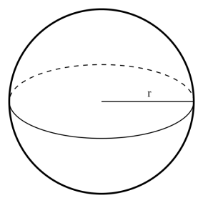
What is the radius of a sphere that has a volume of 179.5 in³? (Round to the nearest tenth.)

Calculate the volume in terms of pi ($π$).
Some questions on the GED test could ask you to leave the answers to the questions in terms of pi. If the answer choices are left in terms of pi or if the question asks you to answer in terms of pi, then you will leave pi as the symbol in the answer. Try some practice problems.

What is the volume of a pipe in cubic feet that has a diameter of 18 inches and a length of 14 feet? Leave the answer in terms of pi.

The volume of a cone is 30$π$ cm³. What is the height of the cone if the diameter is 6 cm?

A sphere has a diameter of 8 inches. What is the volume in terms of pi?

Formula Challenge!
In order to successfully use formulas for the Mathematics sections of the GED test, you will need to pay close attention to the details of the questions that are asked. Be sure to pay close attention to the units being used and what dimensions are actually given. You will not always be given the dimensions that the formulas ask for. You may have to find a dimension or even use another formula to find the dimension. Take a look at the next few problems and try to answer the questions being asked.
- An ice cream company sells two different sizes of ice cream in cylinder shaped containers. One container has a diameter of 4.2 inches and a height of 5.5 inches. The other container has a diameter of 9 inches and a height of 5.5 inches. How many times more ice cream does the larger container hold?

- A model of a volcano is constructed in the shape of a cone. The volcano has a diameter of 8 inches. If the volcano is about 201 in³, how tall is the model?

- Becka is trying to find the volume of a soccer ball. She knows the circumference of the ball is 22$π$ cm. Can you help her find the volume of the ball?

- LearnZillion Problem
Four cubes of ice with an edge 4 cm each are left to melt in a cylindrical glass with a radius of 6 cm. Ignoring the fact that ice takes up slightly more space than liquid water, how high will the water rise when they have melted? (Note: The glass is empty before the ice is added.)
(*Highlight the key details in the problem before working the problem.)

