Lesson 3: Instructional Delivery
When solving mathematical problems, you first have to be sure you know what the problem is asking and what information is given. You will also need to be sure to use the appropriate sources needed to solve the problems. When asked questions about the surface area of an object, you will need to know the shape of the object and which formula or formulas to use. You will need to determine if you are asked to find the surface area or maybe a missing side length. You may even have to convert units of measure depending on the information given in the problem.
Surface Area of Rectangular Prisms
Pay close attention to the following rectangular prisms.
Can the surface area of each of the rectangular prisms be calculated? Will the surface area be the same or different?
What information do you need to calculate the surface area? What do you need to pay close attention to?
6 ft
2 ft
6 ft
2 ft
2 ft

2 ft

Compare the following two rectangular prisms. Can their surface areas be calculated? Will the surface areas be the same or different? What information do you need to calculate the surface area? What do you need to pay close attention to?
48 in

24 in
2 ft
4 ft
24 in
2 ft

Surface Area of Right Prisms
Take a look at the following right prisms.
How are they different from the rectangular prisms?
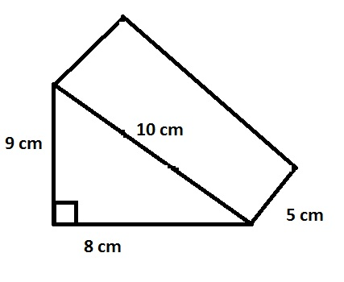
How will calculating the surface area for a right prism be different than calculating the surface area of a rectangular prism?

What is the formula for the surface area of a right prism?
What is the base of the prism? What is the height? What does “p” mean in the formula?

Use the dimensions from the picture above. Find the surface area of the prism.

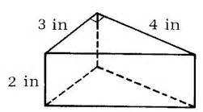
Take a look at these prisms. Locate the base and height. What information do you need to solve for the surface area? Find the surface area.
6 ft

2 ft

3 ft

Surface Area of a Pyramid
Take a look at the following pyramids.
How are they different from the rectangular prisms?
How will calculating the surface area for a pyramid be different than calculating the surface area of a rectangular prism?
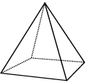
6 in

3 in

What is the formula for the surface area of a pyramid?
What is the base of the pyramid? What is the slant height? How can you find “p” and “s” for the formula?

Use the dimensions from the picture above. Find the surface area of the pyramid.

Look at this pyramid below. What information do you need to solve for the surface area? Locate the base and height. Calculate the surface area.
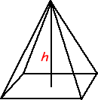
The pyramid has a base edge with a length of 22 cm and a slant height of 48 cm. What is the surface area?

Discussion: If you were only given the height instead of the slant height, could you use a formula to find the slant height?

Formula Challenge!
In order to successfully use formulas for the Mathematics sections of the GED test, you will need to pay close attention to the details of the questions that are asked. Take a look at the next few problems and try to answer the questions being asked.
- Jacob bought his son a fish tank for his bedroom. The tank came with a fish hotel decoration that his son can paint. The hotel is a rectangular prism shaped piece of plastic. Jacob will have to purchase paint for the hotel. The paint costs $2.50 per bottle and each bottle covers approximately 2 square feet. If the fish hotel has a length of 12 inches, a width of 8 inches, and height of 9 inches, how much will the paint cost?

- Candi is building planters for her patio. She wants each one to hold 8 cubic feet of dirt. The height of each planter will be 2 feet. If the base of the planter is a square, what is the length of each side of the base? Candi is thinking about tiling the outside of two planters. If she only tiles the surfaces that someone will actually see, how many square inches of tile will she need for two planters?

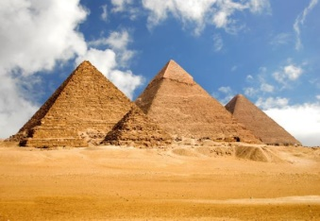
- Sarah is working on a project for her Social Studies class. Previously, she determined the height for the smaller pyramid in the picture. She has decided to use the smaller pyramid to make a scale model. The base will have a side length of 8 inches and the slant height of the pyramid will be 10 inches. She wants to cover all surfaces of the pyramid with sand. She will need glue and sand to do this. The glue will be brushed on like
paint. How many square inches of glue will she need? If the sand
comes in containers that will cover approximately one cubic foot, how
many containers of sand will she need?

- Try the problem presented in the video: https://learnzillion.com/lesson_plans/2571
