Hardin
Supplementary Information - During the brainstorming activity, students should dissect prompt for key vocabulary (in blue) and questions that require answers (in bold).

Prompt 1 Time to Reflect page 596 for Instructional Delivery
Mrs. Lightfoot has chronic kidney failure. She travels to a dialysis center three times a week for hemodialysis. The van will be arriving at your nursing center in 1 hour to pick her up. Mrs. Lightfoot has a fistula in her right forearm. The nurse asks you to provide AM care for Mrs. Lightfoot, obtain her weight, and measure her vital signs. What factors must you consider while offering this care? Does it matter which arm you use for her blood pressure? When Mrs. Lightfoot returns from her dialysis session, she is usually very tired. How would you care for her upon her return?

Prompt 2 Time to Reflect page 463 for Guided Practice
The doctor has come to do Ms. Groves’s annual exam. The nurse explains to Ms. Groves that the doctor wants to perform a pelvic exam. The nurse asks you to transport Ms. Groves to the center’s exam room and prepare her for the examination. You have just finished measuring her vital signs when Ms. Groves begins to cry. She asks you if the pelvic exam will hurt and tells you she is too afraid to continue. How would you react in this situation?

Prompt 3 Time to Reflect page 608 for Independent Practice
Mrs. Westfield is an 87-year-old resident who was admitted to your care center 3 weeks ago. She needs assistance with her personal hygiene. She is incontinent and wears a brief. She becomes very agitated and uncooperative when you assist her with perineal care. She is particularly uncooperative when male staff members assist with her personal care. Mrs. Westfield’s daughter attended the care conference this week. She shared with the staff that her mother was raped when she was 20 years old. Why is this information important? How could something that happened more than 60 years ago be significant today? Should this information be passed on to the caregivers? What measures can be put in place to help Mrs. Westfield as care is offered?

STUDENT WRITING GUIDE AND CHECKLIST
- determine which position presented in the passage(s) is better supported by evidence from the passage(s)
- explain why the position you chose is the better-supported one —remember, the better-supported position is not necessarily the position you agree with
- defend your assertions with multiple pieces of evidence from the passage(s)
- build your main points thoroughly
- put your main points in logical order and tie your details to your main points
- organize your response carefully and consider your audience, message, and purpose
- use transitional words and phrases to connect sentences, paragraphs, and ideas
- choose words carefully to express your ideas clearly
- vary your sentence structure to enhance the flow and clarity of your response
- reread and revise your response to correct any errors in grammar, usage, or punctuation

RUBRIC FOR SCORING WRITTEN REPONSE
Trait Criteria | 0 | 1 | 2 | Score
1. Creation of Argument/Use of Evidence | May attempt to create an argument OR lacks purpose or connection to the prompt- or does neither | Generates an argument and demonstrate some connection to the prompt | Generates TEXT-based argument(s) and establishes a purpose that is connected to the prompt
 | Cites minimal or no evidence from the source text(s) (sections of text may be copied from source) | Cites some evidence from the source text(s) to support argument (may include a mix of relevant and irrelevant citations or a mix of textual/non textual references) | Cites relevant and specific evidence from the source text(s) to support argument (may include a few irrelevant pieces of evidence or unsupported claims)
 | Minimally analyzes the issue and/or evaluation the validity of the argument within the source texts; may completely lack analysis or demonstrate minimal or no understanding of the given argument(s). | Partially analyzes the issue and/or evaluates the validity of the argumentation within the source text; may be simplistic, limited or inaccurate | Analyzes the issue and or/evaluates the validity of the argumentation within the source texts (e.g. distinguishes between supported and unsupported claims, makes reasonable inferences about underlying premises or assumption, identifies fallacious reasoning, evaluated the credibility of sources)
2. DEVELOPMENT OF IDEAS AND ORGANIZATIONAL STRUCTURE | Contains ideas that are insufficiently or illogically developed, with minimal or no elaboration on main idea  Contains an unclear or no progression of ideas; details may absent or irrelevant to the main idea(s) | Contains ideas that are inconsistently developed and/or may reflect simplistic or vague reasoning; some ideas are elaborated upon  Demonstrates some evidence of a progression of ideas, but details may be disjointed or lacking a connection to the main idea | Contains ideas that are well developed and generally logical; most ideas are elaborated upon  Contains a sensible progression of ideas with clear connections between details and main points
 | Establishes an ineffective or no discernable organizational structure; does not apply transitional devices or does so inappropriately  Uses an informal style and/or inappropriate tone that demonstrates limited or no awareness of audience or purpose | Establishes an organization structure that may inconsistently group ideas or is partially effective at conveying the message of the task; uses transitional devices inconsistently  May inconsistently maintain a formal style and appropriate tone to demonstrate an awareness of the audience and purpose of the task | Establishes an organizational structure that conveys the message and purpose of the response; applies transitional devices appropriately
 | May frequently misuse words, overuse slang or express ideas in a vague or repetitious manner | May occasionally misuse words and/or choose words that express ideas in vague terms | Chooses specific words to express ideas clearly
3. CLARITY AND COMMAND OF STANDARD ENGLISH CONVENTIONS | Demonstrates consistently flawed sentence structure such that meaning may be obscured; demonstrates minimal control over skills 1-5 as listed in Score Point 2 to right. | Demonstrates inconsistent sentence structure; may contain some repetitive, choppy, rambling, or awkward sentences that may detract from clarity; demonstrates inconsistent control over skills as listed in Score Point 2 1-5 to right. | Demonstrates largely correct sentence structure and a general fluency that enhances clarity with specific regard to the following skills:  1) varied sentence structure within a paragraph or paragraphs  2) correct subordination, coordination and parallelism  3) avoidance of wordiness and awkward sentence structures  4) usage of transitional words, conjunctive adverbs and other words that support logic and clarity  5) avoidance of run-on sentences, fused sentences, or sentence fragments
 | Demonstrates minimal control of basic conventions with specific regard to skills 1 – 7 as listed Score Point 2 to right. | Demonstrates inconsistent control of basic conventions with specific regard to skills 1 – 7 to right. | Demonstrates competent application of conventions with specific regard to the following skills:  1) frequently confused words and homonyms, including contractions  2) subject-verb agreement  3) pronoun usage, including pronoun antecedent agreement, unclear pronoun references, and pronoun case  4) placement of modifiers and correct word order  5) capitalization (e.g., proper nouns, titles, and beginnings of sentences)  6) use of apostrophes with possessive nouns  7) use of punctuation (e.g., commas in a series or in appositives and other non-essential elements, end marks, and appropriate punctuation for clause separation)
 | Contains severe and frequent errors in mechanics and conventions that interfere with comprehension; overall, standard usage is at an unacceptable level for on-demand draft writing.  OR  Response is insufficient to demonstrate level of mastery over conventions and usage | May contain frequent errors in mechanics and conventions that occasionally interfere with comprehension; standard usage is at a minimally acceptable level of appropriateness for on- demand draft writing. | May contain some errors in mechanics and conventions, but they do not interfere with comprehension; overall, standard usage is at a level appropriate for on-demand draft writing
Total Score | 16-18 = Well Done 13-15 = Good Job 11-12 = Met minimum standards 10 and below = Needs Improvement

Adapted from The 2014 GED® Test – Reasoning Through Language Arts (RLA) Extended Response Resource Guide for Adult Educators, October 2013, https://www.gedtestingservice.com/uploads/files/949aa6a0418791c4f3b962a4cd0c92f4.pdf.

Introductory Worksheet: How do you solve a problem like Maria?

- A student goes to the bookstore to purchase Mosby’s Textbook for Long-Term Care Nursing Assistants. The cost of the book plus sales tax is $68.41. Store policy states that cashiers must give change using the least amount of bills and coins. If the student gives the cashier a $100 bill, how much and what denominations of change should be expected?
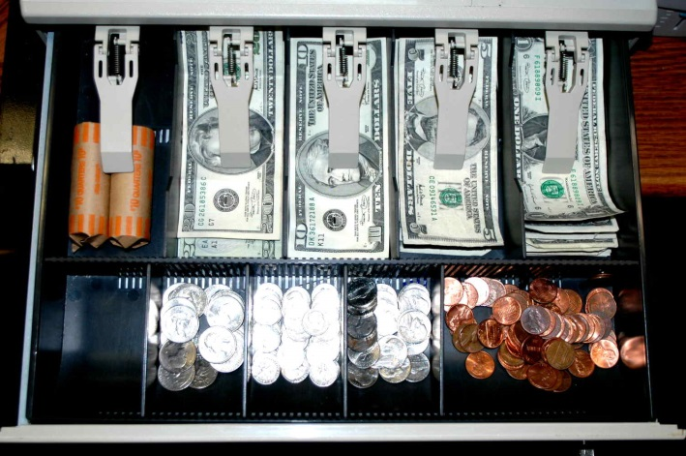
Number of Denomination_ Number of Coins
________ $20 ________ quarter
________ $10 ________ dime
________ $5 ________ nickel
________ $1 ________ penny

http://sonitrolwc.com/wp-content/uploads/2015/06/Cash-drawer.jpg

- A nursing student drives to the city high school to take their state registered nurse’s aide class. When they enter the parking lot, they see a sign that states tonight’s class has been moved to the city library. Draw your travel route going from the front of the city high school to the front of city library.
http://www.enchantedlearning.com/geography/mapreading/city/map.GIF
