Hardin

Part 1 Worksheet - Respiration Rates and Breathing Graphs
- A nurse’s assistant is recording vital signs for various patients. Convert the breaths counted in 30 seconds to respiration rate per 1 minute, then circle the appropriate classification as normal breathing, tachypnea, or bradypnea.
Patient D
3 breaths = ________
30 sec 60 sec

normal brachypnea
tachypnea

Patient C
12 breaths = ________
30 sec 60 sec

normal brachypnea
tachypnea

Patient B
7 breaths = ________
30 sec 60 sec

normal brachypnea
tachypnea

Patient A
5 breaths = ________
30 sec 60 sec

normal brachypnea
tachypnea

- Another nurse’s aide marked Patient E’s respiration rate as 75 breaths over 5 minutes. You repeat the measurement as count 4 breaths in 30 seconds. What reasons could explain why the ratios are not equivalent? ______________________________________________________________________
- What would be the two unit rates (breaths per minute) for Patient E? ________________________________________________________________
- Over the extended time, would Patient E’s respiration rate be considered normal? ______________________________________________________

- Choosing to count breaths over 30 seconds, 60 seconds, or even longer depends on the patient’s breathing conditions. Determine the patient’s respiration rate over various amounts of time.
Patient J
18 breaths = ________
45 sec 60 sec

normal brachypnea
tachypnea

Patient G
9 breaths = ________
20 sec 60 sec

normal brachypnea
tachypnea

Patient H
45 breaths = ________
3 min 60 sec

normal brachypnea
tachypnea

Patient F
2 breaths = ________
7 sec 60 sec

normal brachypnea
tachypnea

Some patients require monitoring over lengthy periods of time to detect abnormalities. A respiratory mechanics monitor would create various graphs for physicians and respiratory specialists to use in creating a health care plan.
Notice the graph at the left resembles waves in the ocean. This repeating pattern may be described as a sine wave with a little modification due to the pause people take between breaths. One breath starts with the inhalation (or intake of air) which you notice when a patient’s chest rises. Then the patient’s chest falls when he exhales (or breaths out air) and there is a second or two rest before the next breath starts.
6. What is being measured on the x-axis of the graph?
7. How many breaths occurred in 15 seconds?
8. What is measured on the y-axis of the graph?
9. How much air is taken in during inhalation?
10. Calculate the breathing rate per minute for this patient.

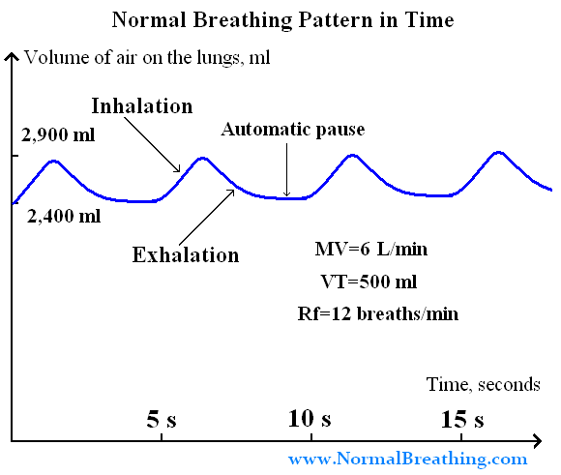

11. If the patient intakes 500 ml per breath and breaths with a frequency of 12 breaths per minute, what is the total amount of air the patient would
require in one minute of normal breathing?
_______________________________________________________________________________

12. How does your amount of air drawn in compare to the amount on the graph (MV=6 L/min)? Explain your mathematical reasoning.
________________________________________________________________________________________________________________
________________________________________________________________________________________________________________
________________________________________________________________________________________________________________
_________________________________________________________________________________________________________________

13. Count a partner’s breaths for 30 seconds and record the data. Repeat with 3 more thirty second counts. Determine the average breathing rate and make a graph similar to what you see above. Use the “normal” values of 2,400 ml residual air in the lungs and 500 mL of air with each breath.

Interpret whether a patient’s breathing is normal, shallow, or deep depending on the amplitude or air intake on the breathing graph.
15. Respiration Rate ___________________
Circle One: Normal Shallow Deep
14. Respiration Rate ___________________
Circle One: Normal Shallow Deep
Volume of Air in Lungs
Volume of Air in Lungs
60
20
40
18. Using the others as models, create your own graph for the patient who breaths normally for one breath, then takes 4 quick, shallow breaths, seems to stop breathing for 5 seconds, then takes 2 long, deep breaths all within 1 minute.
17. What changes in these graphs? Both the wave height and the wave length change and show a relationship. As the wave height increases, the wave length ________________.
16. Rate ___________________
Circle One: Normal Shallow Deep
Time in seconds
30 s
15 s
Time in seconds
30 s
15 s
Time in seconds
2400 mL
2400 mL
2400 mL
2900 mL
2900 mL
2900 mL
Volume of Air in Lungs
Volume of Air in Lungs
Time in seconds
2400 mL
2900 mL
30 s
15 s

