Blitz 2
Worksheet 1

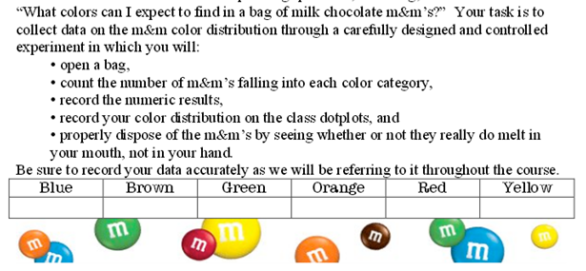
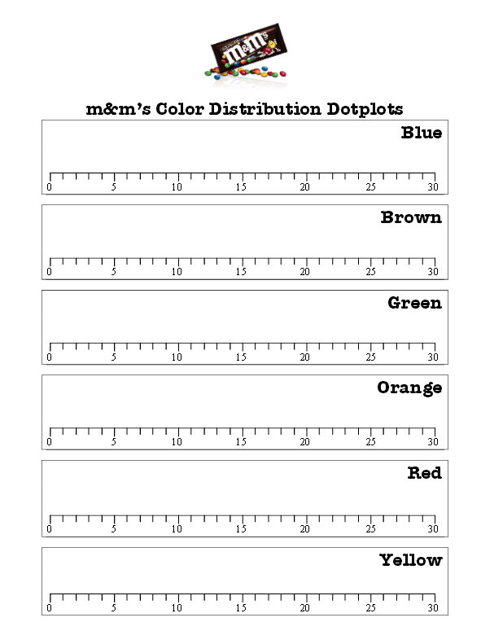

Worksheet 2

Activity Worksheet 2: Mean and Median Range and Mode

- Fill in the information below with the results from both bags of M&M’s.

Color | Blue | Orange | Green | Yellow | Red | Brown | Total
Bag 1 Number
Bag 2 Number

- Based on the information above answer the following questions:
  - What is the average number of M&M’s per bag?
  - What is the average of blue M&M’s?
  - Calculate the average of each color and record in the chart:

Color | Blue | Orange | Green | Yellow | Red | Brown | Total
Average

- What is the range between the blue and brown M&M’s?
- Is there a mode? If so, what is the mode?

- Create a pie Chart based on the results collected. Use your bag 1 results

Pie Chart

Worksheet 3
You have to plan Easter dinner at the restaurant. In order to create work schedules and order food you need to review last year’s attendance.
Read the table below and answer the questions:

- Complete the chart below:
Attendance in ballroom 1 | Attendance in ballroom 2 | Attendance in Main Room | Attendance in VIP Room

- What was the total number of people eating Easter dinner in 2016?
- How many servers worked that day?
- You are expecting an increase of 10% in attendance this Easter. How many people should you expect?
- You have a total of 55 employees scheduled to work on that evening. Dinner in ballroom 1 starts at 6p.m., dinner in ballroom 2 starts at 7:30 p.m., dinner in the Main room and VIP room starts at 8: 00p.m. All employees should be setting the room and tables 3 hours before dinner starts, and they should arrive to work 30 minutes before work start in order to get instructions, What will the work schedule look like? Complete the schedule using the template below:
Room | Time in | Start room set up | Break | Serve dinner | Clean up | Time out
Ballroom 1

Ballroom 2

Main Room

VIP room

Graph and Charts QUIZ:
