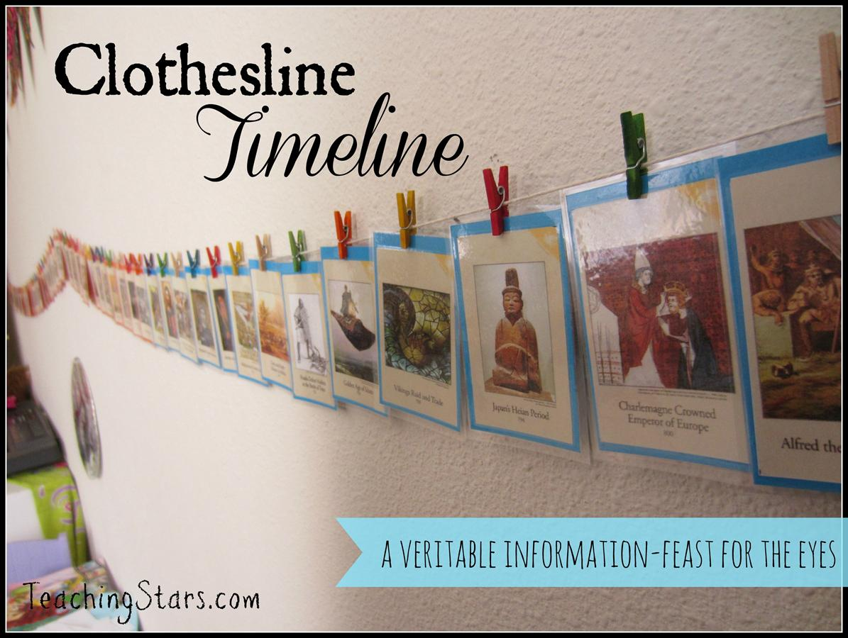

Instead of pictures, we will hang little boxes. We are going to put the main ideas and supporting events of each historical event in the boxes, marked by placing the date on a piece of paper above each box.
For final review, the boxes will be taken off the clothesline; paper dumped on a table and mixed up. Students will then put boxes at proper date on the time line, and then place tabs of paper in the proper box.

