Lesson 4
Activating Activity:
During the last lesson we discussed different methods for covering the interior of a rectangular shaped pool. Let’s use the cylindrical shaped pool from lesson 2. What if we want to spruce up the interior of that pool before filling it with water? What information will I need to determine the cost of covering the interior of the cylindrical pool?

The cylindrical pool has a diameter of 10 feet and a depth of 5.5 feet.

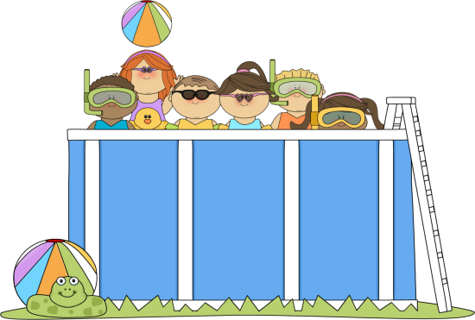
Make a prediction. How will the costs change?

Lesson 4: Formula Discussions
Surface Area: Discussion
Let’s discuss the formulas in detail and then come back to the pool problem!
Use the formulas on the GED formula sheet.
Figure | Surface Area Formula | Name each variable | Describe each piece of the formula using the help of a net
Cylinder | SA=
Cone | SA= |  | 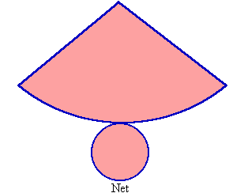
Sphere | SA= |  | 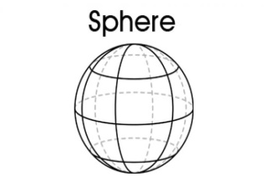
Discussion: Use the nets and surface area formulas above to discuss the pieces of each of the formulas. Label the nets with each piece of the formulas.
Notes:

How is the surface area formula for a cylinder similar to the surface area formula for a prism?

How are they different?

How is the volume formula for a cone similar to the volume formula for a pyramid?

How are they different?

