Lesson 4
Connections / Extensions:
Previously you found the volume of the glasses pictured below. You are now interested in decorating the outside surfaces of the glasses.
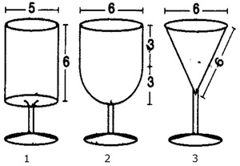
The measurements for all three glasses are in centimeters. The glasses are not drawn to scale.
6
6
6

6

- What information do you need to know how much material is required to cover the exterior of each glass?

- Write the formulas required for each glass. Are there any pieces of the formulas that are not needed?

- Calculate how many square centimeters of material are needed for each glass.

- Compare the surface area of each of the glasses. Do your answers make sense? Write your explanation of how the surface areas compare using appropriate math terms.

