Lesson 4: Guided Practice 1:
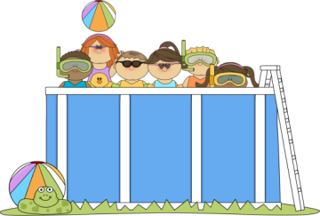
Spruce up the interior of the pool! What information will I need to determine the cost of covering the interior of the cylindrical pool?
The cylindrical pool has a diameter of 10 feet and a depth of 5.5 feet.
Make a prediction. How will the costs change?

I will be covering the inside surfaces of the pool. How many square feet will I cover?

One gallon of paint will cover 250 square feet and cost $48.97 per gallon. How many gallons will I need to buy and how much will it cost?

A 1-square foot sheet of glass tiles costs $4.75. How much will it cost to tile the pool?

How much more will it cost to tile the pool?

Guided Practice 2:
The ice cream shop wants to make wrappers to cover each cone. The wrapper will cover the entire cone and have a flap that will cover the circular opening. Each cone has a 4 inch diameter and a slant height of 4 inches?

The paper for the wrappers is a 12 inch by 12 inch sheet. How many sheets will be needed to cover a case of cones? There are 300 cones per case.

The paper is delivered in packages of 25 sheets. How many packages are needed for each case of cones and how much will each deliver cost if the company charges $12.95 per package?

Guided Practice 3:
Mary is going to put glitter on spherical Christmas ornaments. The ornaments have a circumference of 4 inches.
How much glitter will she need for each ornament?

Glitter is sold for $3.75 per container and ornaments are sold for $10.95 per dozen. Each container of glitter will cover 25 square feet. How much will it cost her to make 2 dozen ornaments?

