Lesson 4: Instructional Delivery:
Use the formulas for the surface area of cylinders, cones, and spheres to solve and compare the following problems. Remember the details from the previous lesson about units of measure.
Compare the cylinders. Can the surface area be calculated? Will the surface area be the same or different?
6 ft

24 in
6 ft

2 ft

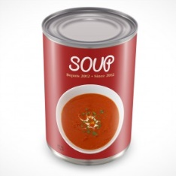
What if you were given the surface area of the cylinder and need to determine a missing dimension? The surface area of the can below is 75.36 in². If the height is 4 inches, what is the radius?
4 in

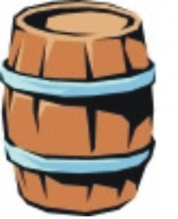
You are given the surface area of a barrel and asked to determine if it will sit on a table that is 8 feet wide and 8 feet long. What do you need to determine?
The surface area of the barrel is 246.8825 ft². The height is 5 feet.
Will the barrel fit on a table that is 8 feet long and 8 feet wide?

Surface Area of Cones:
We have discussed that cones are 1/3 the volume of the cylinder of the same base and height.
Compare the surface areas of the cylinder and the cone.
The two containers have the same radius and the same height. What is the surface area of each?
Both objects have a radius of 3 cm and a height of 4 cm. The slant height of the cone is 5 cm.
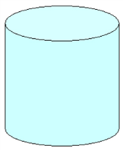
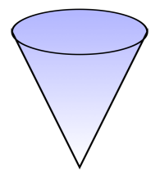

Surface Area of a Sphere:
What is the surface area of a ball with a radius of 6 inches?

What is the surface area of a ball with a radius of 24 centimeters?

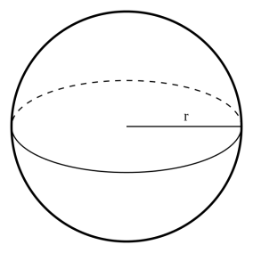
What is the radius of a sphere that has a surface area of 78.5 in²? (Round to the nearest tenth.)

Calculate the surface area in terms of pi ($π$).
Some questions on the GED test could ask you to leave the answers to the questions in terms of pi. If the answer choices are left in terms of pi or if the question asks you to answer in terms of pi, then you will leave pi as the symbol in the answer. Try some practice problems.

What is the surface area of a pipe in square feet that has a diameter of 18 inches and a length of 14 feet? Leave the answer in terms of pi.

The surface area of a cone is 30$π$ cm². What is the slant height of the cone if the diameter is 6 cm?

A sphere has a diameter of 8 inches. What is the surface area in terms of pi?

Formula Challenge!
In order to successfully use formulas for the Mathematics sections of the GED test, you will need to pay close attention to the details of the questions that are asked. Be sure to pay close attention to the units being used and what dimensions are actually given. You will not always be given the dimensions that the formulas ask for. You may have to find a dimension or even use another formula to find the dimension. Take a look at the next few problems and try to answer the questions being asked.
- An ice cream company sells two different sizes of ice cream in cylindrical, plastic containers. One container has a diameter of 4.2 inches and a height of 5.5 inches. The other container has a diameter of 9 inches and a height of 5.5 inches. How much more plastic is used for the larger container?

- A model of a volcano is constructed in the shape of a cone. The volcano has a diameter of 8 inches. If the volcano has a surface area of 125.6 in², what is the slant height of the model?

- Becka is trying to determine the surface area of a soccer ball. She knows the circumference of the ball is 22$π$ cm. Can you help her find the surface area of the ball?

- GED Free Practice Test
Go to www.GEDTestingService.com
Click on “Educators” and click on “Free Practice Test”.
Click on “Math Test”
Go to Question 10, try to answer the question.
After trying to answer the question, click on “Answers and Explanations”, read through the explanation and compare to your method.
Did you answer it using the same method?
Was your answer correct?

