Lesson 5: Activating Activity:
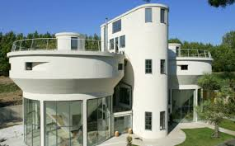
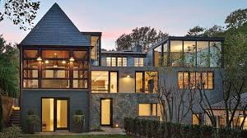
Suppose you are the head contractor over-seeing the building of a house. You could possibly need to know the volume of certain areas of the house as well as the entire house. You may also need to know the surface area of certain areas of the house and the entire house. As we know, most of the homes built are not perfect squares or rectangles. How could you determine the volume of a house that is not a perfect square or rectangular shape? How could you determine the surface area? Use the pictures of the homes to help you think of ideas.

Discussion
We have worked with the formulas for area, perimeter, circumference, volume, and surface area for all of the common 2-dimensional and 3-dimensional shapes that are located on the GED formula sheet. What if you need to find the volume or surface area of an object that does not have a formula listed on the sheet? Could you figure out how to solve the problem?
Think of the volume of your house. Is your house a square or a rectangle with a flat roof? More than likely it is not. Take a look at the pictures above of the two very different, modern style homes. Do you see familiar shapes that the houses could be split into in order to find the volume?

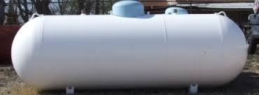
What if you had to find the volume of your propane tank? What familiar shapes do you see?

These objects are considered composite figures. They consist of more than one shape. We can divide the shape into shapes that we know formulas for in order to find their area, volume, surface area, and so on.
You will have to determine what you need to solve for, what shapes are involved in the figure, what dimensions you know and do not know, what formulas are needed, and if the formula needs to be manipulated.

