Lesson 5: Guided Practice: Go to the following site:
http://prezi.com/brwe7rz6jav_/?utm_campaign=share&utm_medium=copy&rc=ex0share
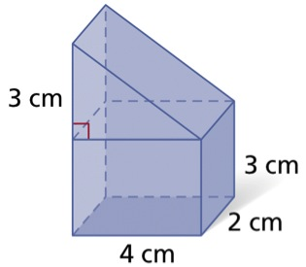
Use the notes sheet to work through the Prezi. Work through this activity on your own, doing as much work as possible and taking notes when necessary. After you are finished, we will discuss the information as a group.
Surface Area:
- What figures make up the composite figure?
- What is the surface area of each figure?
- What part of each figure is on the inside and what is the area of those pieces?
- Add the area of each piece and subtract the area of the inside pieces.
Volume:
What shapes make up the composite figure?
What formulas are needed to find the volume?

Calculate the volume of the figure.
8 cm
4 cm
5 cm
6 cm
Volume:
How do you find the volume of a composite figure?

Think about the following when determining the volume of a composite figure:
What shapes make up the composite figure?
What formulas are needed to find the volume?
Surface Area:
What shapes make up the composite figure?
What formulas are needed to find the surface area?

What surfaces need to be taken away from the combined surface area?

Calculate the surface area of figure.

