Lesson 5: Independent Practice:
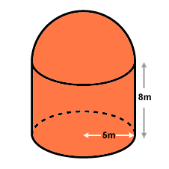
Try to work the following problems. Be sure to pay close attention to the details of the problems and what you may be asked to calculate.
- Find the volume and surface area of the figure.

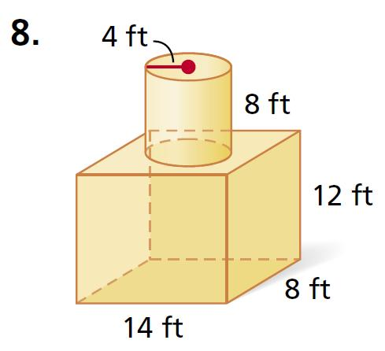

- Find the volume and surface area of the figure.

- If you were to fill this figure with sand, how many
cubic inches of sand would it hold?

- How many square inches of paper would be used to cover the surface?

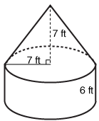
- A farmer wants to build a grain bin similar to the picture. How much metal will be required to build the grain bin? How much grain will it hold?

