Lesson 5: Instructional Delivery: Volume
We have dissected the formulas for volume. The work that was completed in the other lessons in this unit could be useful during this lesson.
Take a look at the following figures. What information is needed to find the volume of the figure?
4 in
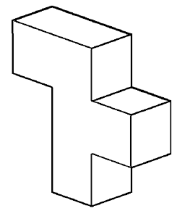
2 in
4 in
4 ft
8 in
4 in
6 ft
4 ft
2 in
4 in
2 ft
8 ft
How can the missing dimensions of the objects be determined?
Try to divide the figures into other shapes, label the missing dimensions, and find the volume of each composite.
5 ft
What shapes is a propane tank composed of?
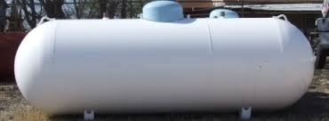
What formulas would be used to determine the volume?
1 ft
Find the volume of the propane tank. The length of the tank
is 5 feet, the radius of the tank is 1 foot.

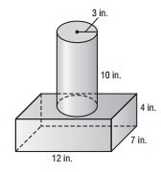
What shapes is this composite solid composed of?
What formulas would you need in order to find the volume?

Calculate the volume for the composite figure.

Instructional Delivery: Surface Area
You have worked with finding the surface area of rectangular prisms, triangular prisms, pyramids, cones, and spheres. If you have a figure composed of two or more of those shapes could you determine the surface area of the figure?
Take a look at the figures. What formulas are needed to find the surface area of the figures? Are there any pieces that are not needed?
2 in
4 ft
4 in
4 in
8 in
6 ft
4 in
2 in
4 ft
2 ft
4 in
8 ft

How can the missing dimensions of the objects be determined?
Try to divide the figures into other shapes, label the missing dimensions, and find the surface area of each composite.
5 ft
What shapes is a propane tank composed of?
What formulas would be used to determine the surface area?
1 ft

Find the surface area of the propane tank. The length of the tank
is 5 feet, the radius of the tank is 1 foot.

What shapes is this composite solid composed of?
What formulas would you need in order to find the surface area?

Calculate the surface area for the composite figure?

