INDEPENDENT PRACTICE
Lesson 9 – Ratios and Proportions

Set up ratios for these items. Simplify them if possible.
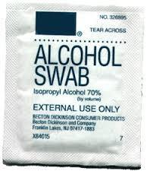
a. alcohol swabs to tongue depressors
b. tongue depressors to total items
c. tongue depressors to alcohol swabs
d. Total items to alcohol swabs

Set up these solutions up as a ratio, and simplify if possible.
a. 5% solution
b. 35% solution
c. 40% solution

Find the unit rate or unit price.
a. There are 48 calories in 12 carrot sticks. How many calories are in one stick?
b. If a bottle of 24 caplets of acetaminophen costs $4.00, how much is one caplet?
c. If 20 mL of solution has 5 grams of pure drug, how much solution is there for 1 gram of pure drug?

On page 97 of Math Basics for the Health Care Professional, do numbers 6-10. Solve for the missing proportion.

On page 100, do numbers 11-20. Using proportions and the chart at the top of page 99, find the conversions for each problem.

On page 101, set up and solve problems 1-5 to find the missing proportions.

