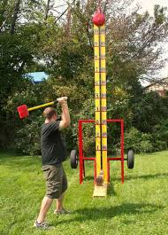
Show your STRENGTH
at the
Funky Town Function Festival

While at the festival, you notice a pattern at the SHOW YOUR STRENGTH GAME. People carrying more weight are getting higher results. You decide to document your data (because you are a nerdy math geek). How do you know how much a person weighs? YOU GUESSED IT--- you were at the GUESS MY WEIGHT booth with them! So you know the weight is accurate
The minimum strength is 10 and the maximum is 200
You have collected the following data:

Weight Strength Marker (10-200)

96 26
120 32
Does this data represent a Function? Explain
What is the best way to present this data?
In WORDS, which would be:
In a TABLE, which would be
In an EQUATION (of the line) , which would be:
In a GRAPH, which would be:
Would a person weighing 220 hit the strength marker at 55? Explain
Base on your weight, what is the ordered pair?
100 27
200 52
112 30
180 47
280 72

Worksheet for your answers

Does this data represent a FUNCTION: YES_____ NO_____
Explain:
____________________________________________________________________________________________________________________________________________________________________________________________________________________________________________________________________________________________________________________________________________________
What data (ordered pair) could you change to make it a function/not a function: (_____,_____)
Explain:
____________________________________________________________________________________________________________________________________________________________________________________________________________________________________________________________________________________________________________________________________________________
Present your data in:
WORDS:
_____________________________________________________________________________________

In a TABLE:
X | Y
In an EQUATION:
_____________________________________________________________________________________

In a GRAPH:
Would a person weighing 220 hit the strength marker at 55? Yes_____ No_____
Would that ordered pair be on the Equation of the line?
Explain:
____________________________________________________________________________________________________________________________________________________________________________________________________________________________________________________________________________________________________________________________________________________

Based on your weight (we will not SHARE in class!) What would your ordered pair be? (_____,_____)

The Famous FUNKY TOWN STUNT MEN (and women!) are performing at the Funky town Festival. The event is two days away, but they are building the ramps today. Because of your LOVE for math, functions, slope, and many other nerdy concepts, you stop to watch.
The project coordinator, tells the crew the height of the ramp must be ½ times the length of the ramp. Because you are a math nerd, you start plotting this information on our coordinate grid sheet that you always keep folded in your pocket.

What is the slope (rate of change) for the ramp?
    - Words, Table, Equation, Graph
Is this a good slope for the ramp? What would you do to make it more challenging? Would you increase the X or the Y (or both) in words and a graph?
You overhear the crew state that since the height has to be 1/2 times the length, that means the length is 2 times the height which is represented a L = 2H . Being the nerd you are, out comes the graph paper. What does that ramp look like using that equation? Is this a correct interpretation of the coordinators instructions?
Which of the ramps is a function?
Which of the ramps is linear?
Which is better for the car jump?
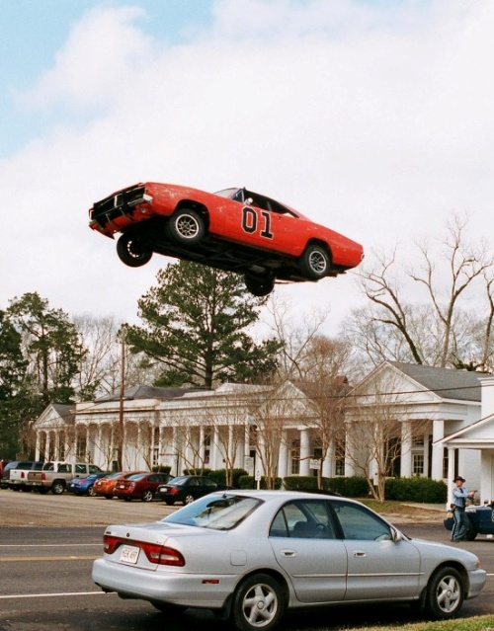
Could the one not best for the car jump be used in another way at the festival STUNTMAN Show?
Why does the equation of a line for a RAMP not have an intercept?

FUNKY TOWN
STUNT MEN at the
Function Festival

You cannot contain your excitement as you hear over the festival loud speaker:
HUMAN CHESS begins in ten minutes. You race to the oversize chessboard (well some call it a chess board, but you know it as the coordinate grid)

And it gets even better, the announcer proudly proclaims a TWIST in the game (No, not the game twister!). Before you can make a move to take out another HUMAN PLAYER, you MUST be able to tell the find the Slope and Equation of the Line between you and the other player. WOW! Can it get any better! YES is can, the announcer throws out all CHESS RULES! So you do not worry about the real rules of chess and focus on the Slope and Equation of a Line (after all, it is math class!)

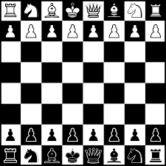

FUNKY HUMAN CHESS for
FUNKY PEOPLE who are at the FUNKY TOWN Function Festival

PICK two or three chess pieces and determine the
LINEAR EQUATION OF THE LINE

Using Y=MX+B

