Comparative Anatomy of Groups and Teams Chart
Comparative Anatomy | Groups | Teams
Roles and Responsibilities | Roles unclear | Roles clear
Rules | Informal and situational | Clearly identified and understood
Goals | Discussed in general terms | Clearly spelled out and focus of teamwork
Methods | Members decide and divide | Members collaborate and cooperate

Anatomy of a Groups Chart
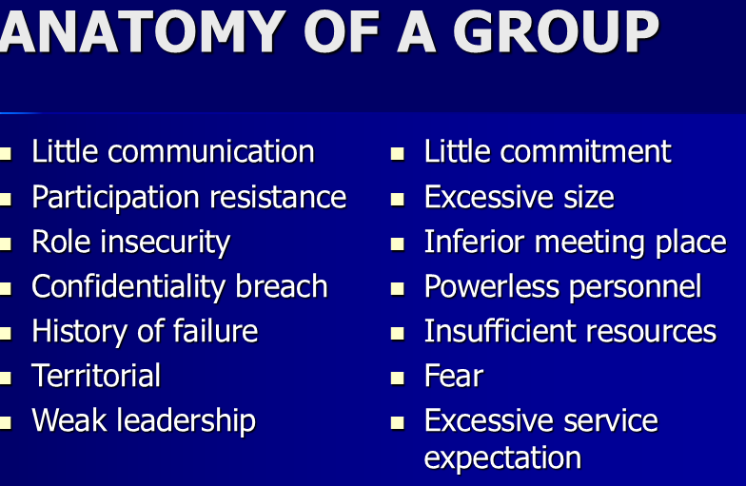

Anatomy of a Team Chart
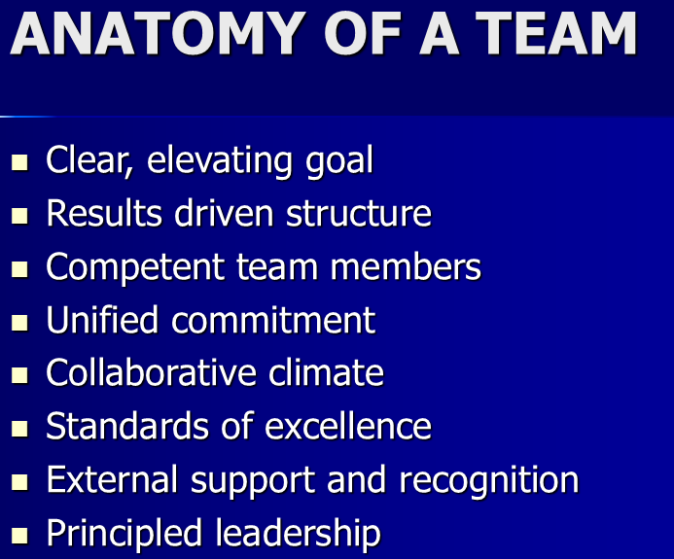

Makers and Breakers Chart
