Using Career OneStop Explorer

1. In your web browser, type in www.careeronestop.org to begin your search.

2. From the homescreen, click “Explore Careers”. Note that you can also view videos and take career placement profile assessments.
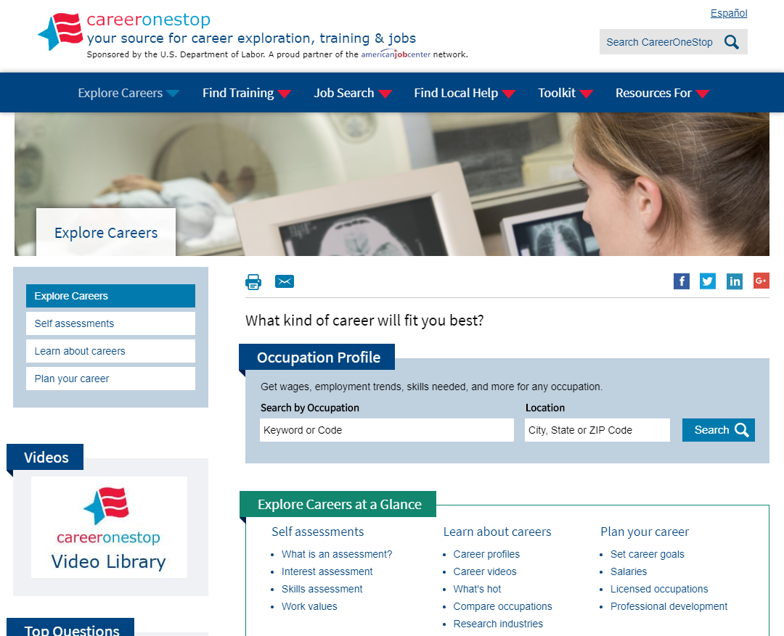
3. Type in the keyword for the job you’re interested in, location (optional) and click “Search”.
4. Using your knowledge of text structures, research the job description, outlook, wages, projected employment, and required education level (plus any additional information you’d like to include). Hint: Printing the screen will allow you to use the post-it note method of note-taking.
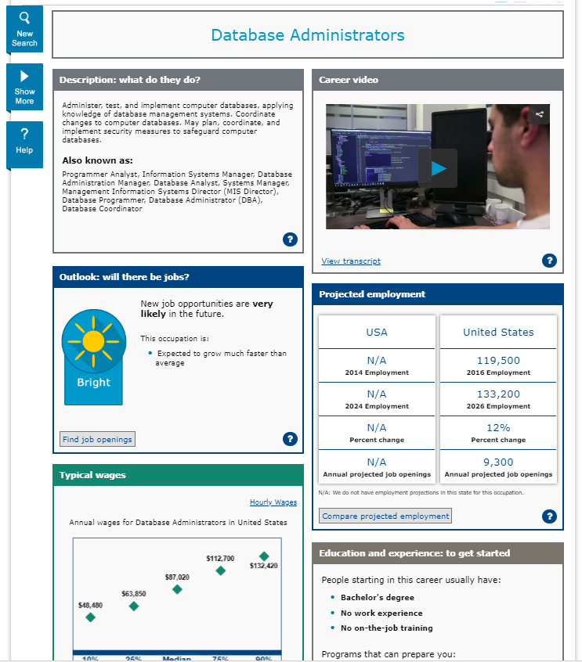
5. Using your notes, develop a short speech about your chosen career that includes all the information you researched, plus:
- Why you chose the career
- What characteristics you have that will help you in the field
- What steps you have already taken to work toward the job
- What steps you still need to take to work toward the job

Career Snapshot Project Rubric
Criteria | Always (3) | Usually (2) | Never  (1)
Research Project
Research accurately includes job description
Research accurately includes outlook
Research accurately includes wages
Research accurately includes projected employment
Research accurately includes education level
Speech
Speaker speaks clearly
Speaker’s pace is appropriate
Speaker includes key details
Speaker uses complete sentences
Speaker makes an effort to answer questions clearly

While listening to your peers, jot down 3 details from each speech.

