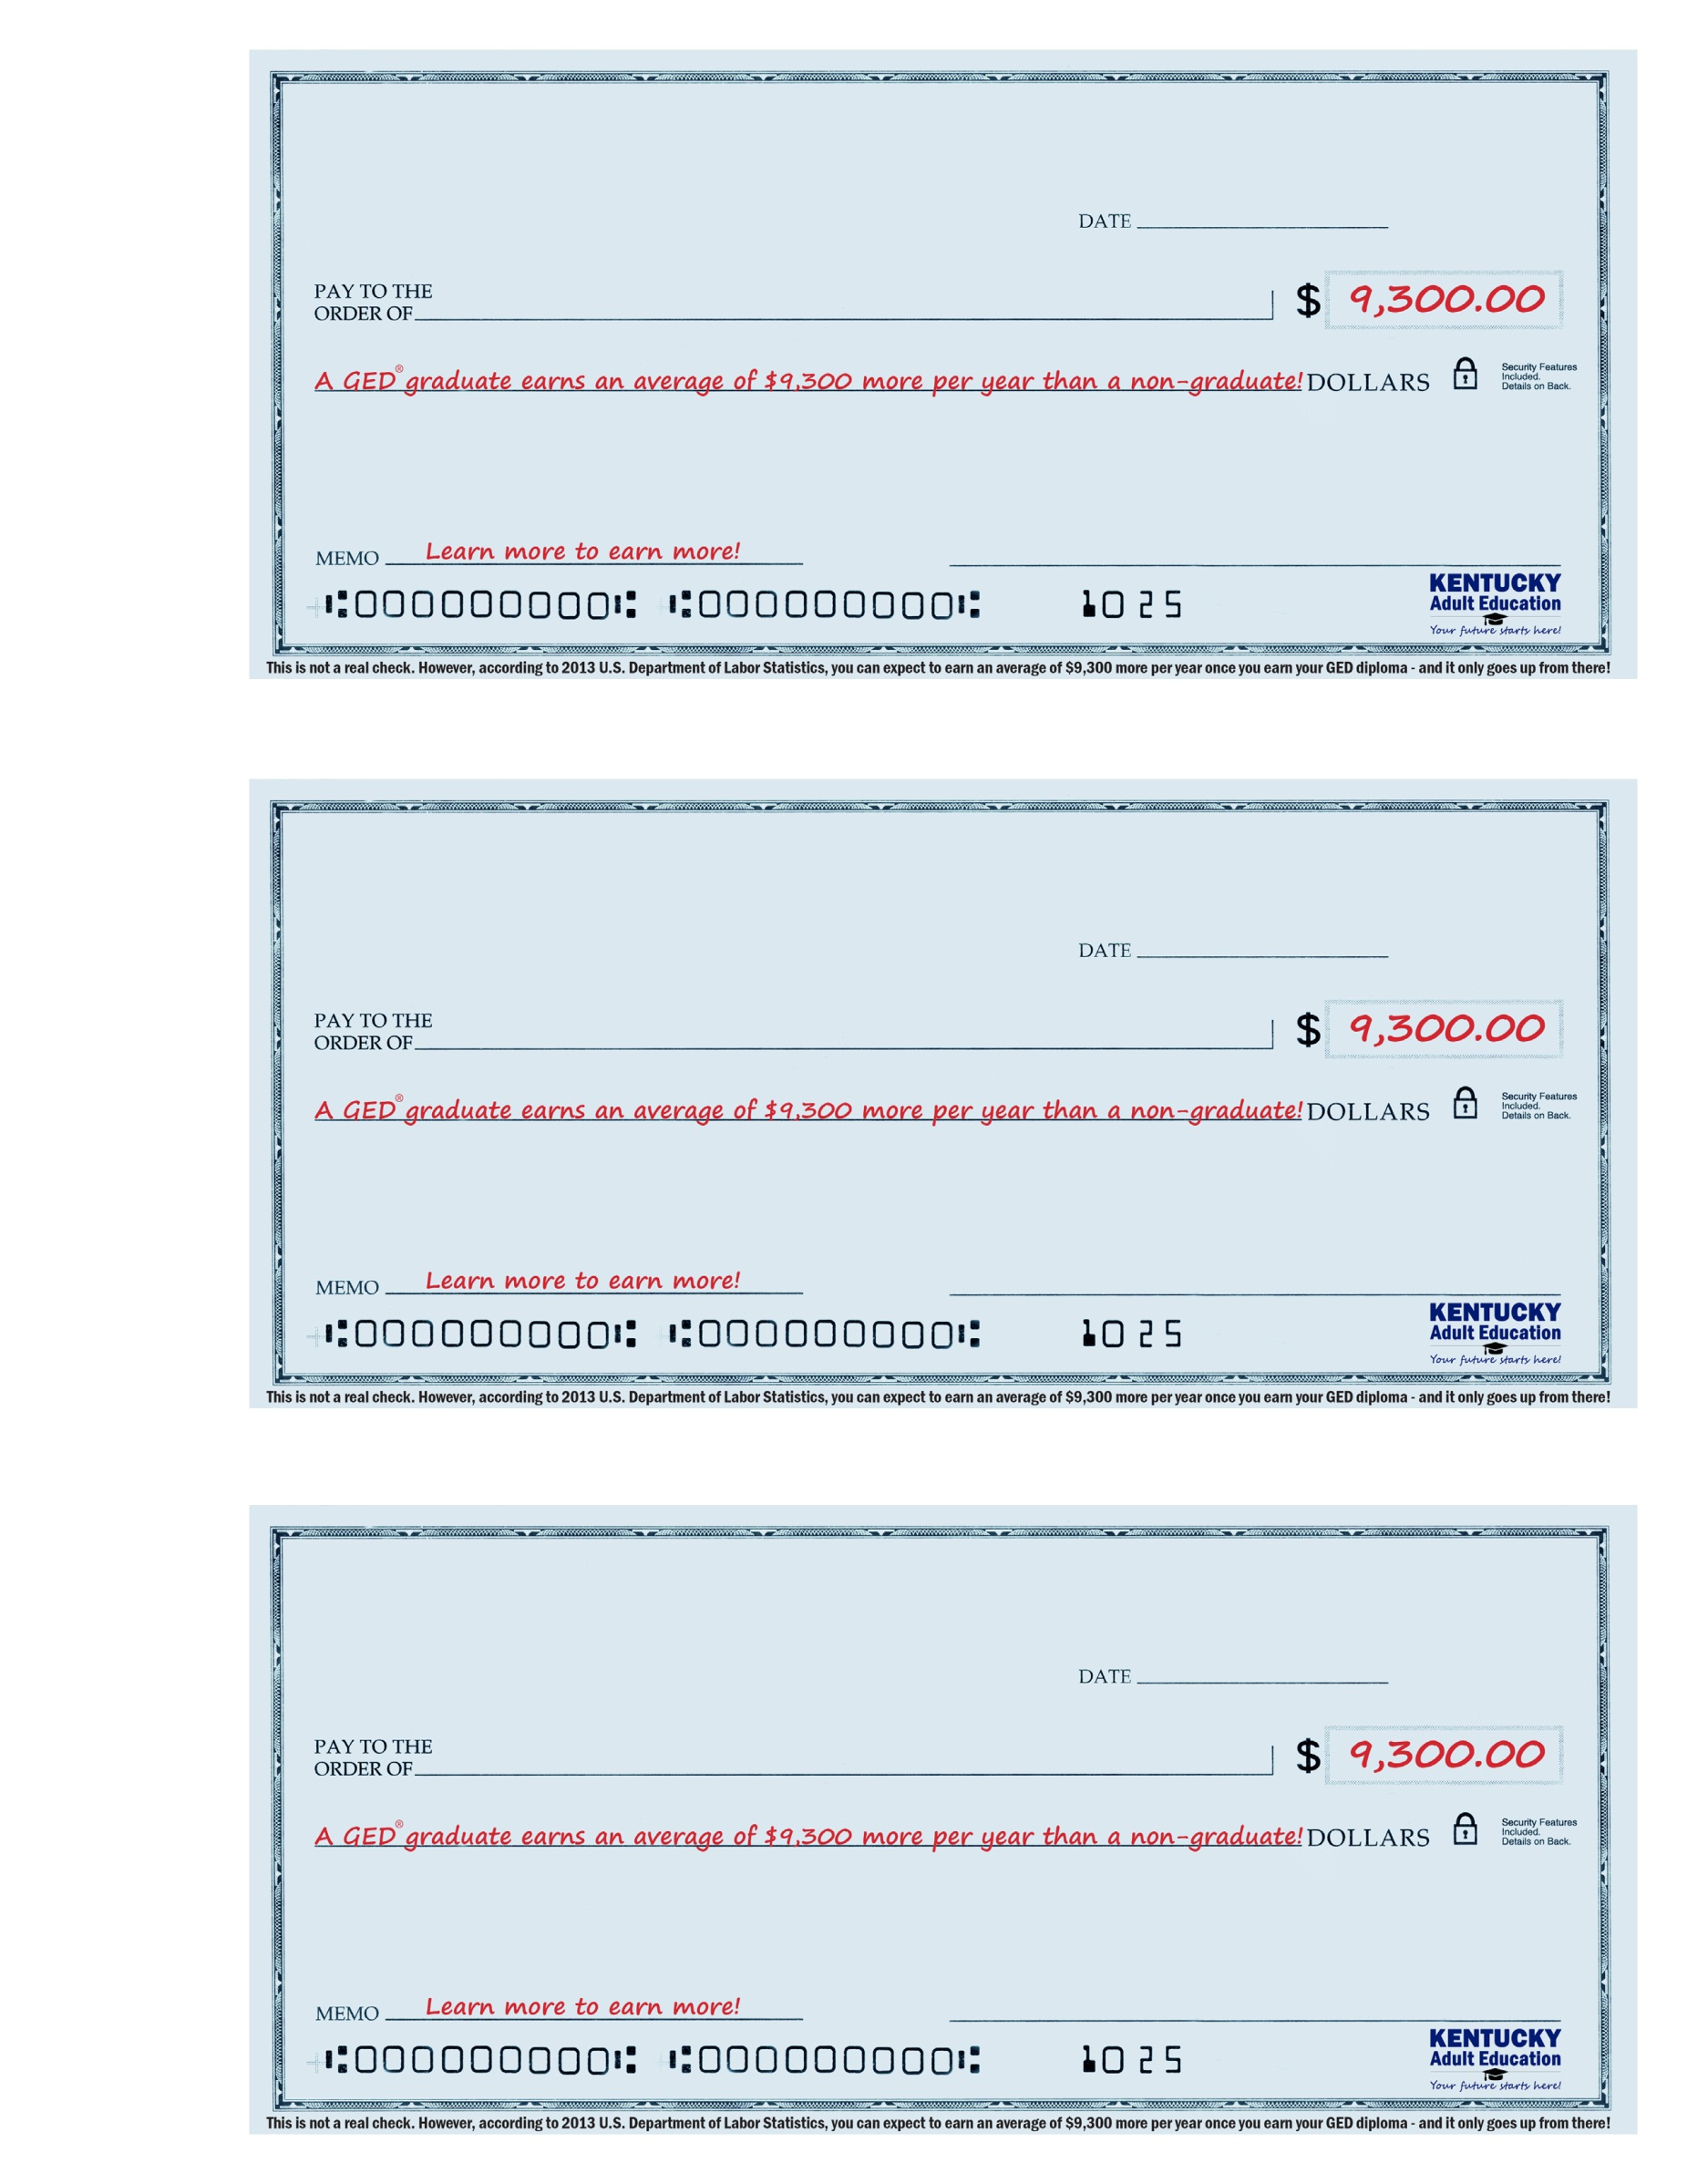w

Program Name

Address

Phone Number

Program Name

Address

Phone Number

Program Name

Address

Phone Number